Background

Html(hypertext markup language) is the name of the code behind the web design and is designed by using a software known as CSS(cascading Style Sheet) and Java.

I designed this project myself and I made it have nice colours so its easy to follow by any kind of age group and sans serif is the most common and the easiest to read when on a website.

Each page follows the same layout, I did this because it will make it easier for elderly and children to follow while looking through the website and clearly shows your options and where to go

The gallery consists of 5 images around Kilkenny in which I had to go around Kilkenny to photograph images that I thought would show Kilkenny for its beautiful scenery rather than the city because I think the journeys along these spots are breathtakingly beautiful.

My target audience is going to be towards older people this is because older people are generally more open to travel and can do so.

My objective for creating the website is to show the history of some Kilkenny areas and to also show the beauty of the castle park and the back of the castle park and just how fresh looking it is. Another was to try interest tourists into coming to Ireland.

The alignment of the website is mostly centered as it makes it easier to read and to follow and just looks a lot neater to follow while doing this website and also looks out for people with ocd but that’s a small detail.

Screenshot

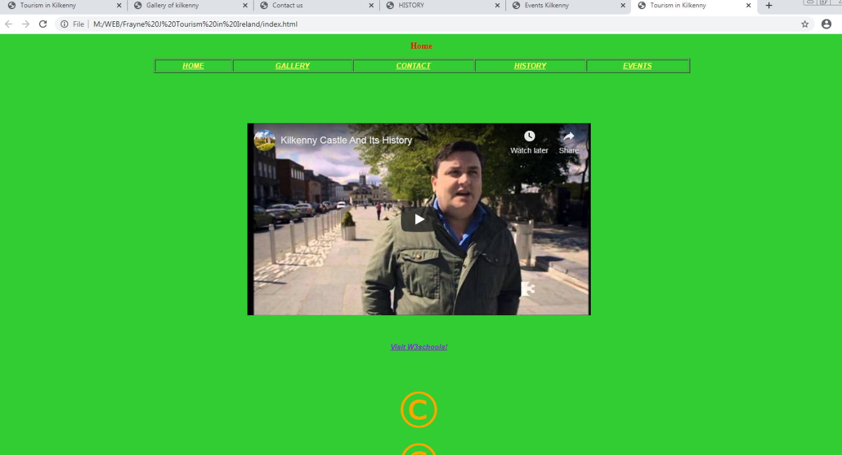

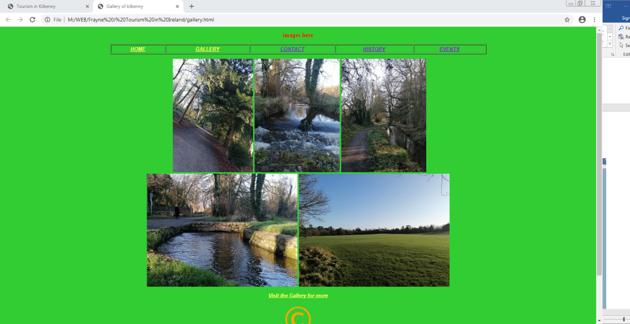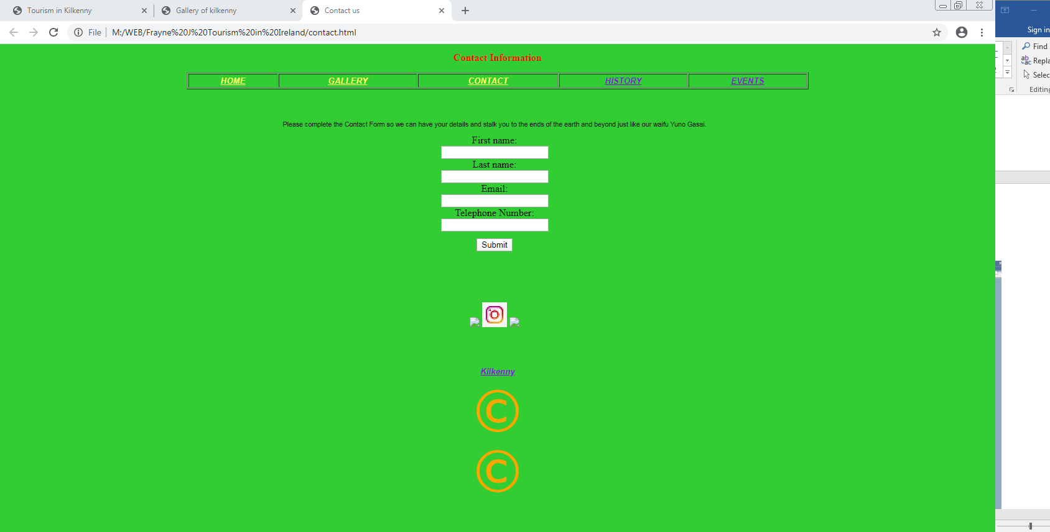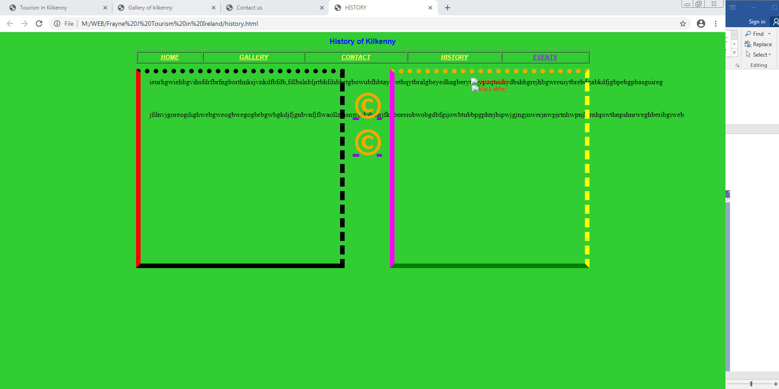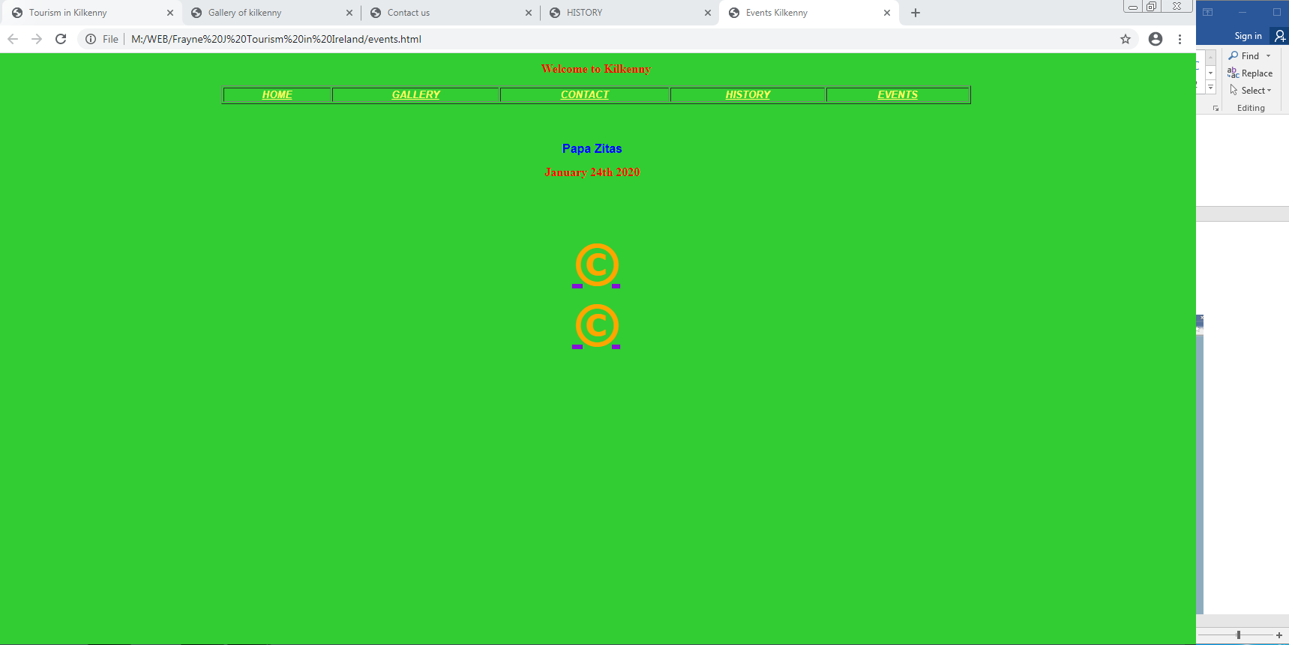

Website used to test: Google Chrome

Starting Page : Index

|  |  |  |  |  |
| --- | --- | --- | --- | --- |
| Index | Gallery | Contact | History | Events |
| ✓ | ✓ | ✓ | ✓ | ✓ |

Starting Page : Gallery

|  |  |  |  |  |
| --- | --- | --- | --- | --- |
| Index | Gallery | Contact | History | Events |
| ✓ | ✓ | ✓ | ✓ | ✓ |

Starting Page : Contact

|  |  |  |  |  |
| --- | --- | --- | --- | --- |
| Index | Gallery | Contact | History | Events |
| ✓ | ✓ | ✓ | ✓ | ✓ |

Starting Page : Contacts

|  |  |  |  |  |
| --- | --- | --- | --- | --- |
| Index | Gallery | Contact | History | Events |
| ✓ | ✓ | ✓ | ✓ | ✓ |

Starting Page : History

|  |  |  |  |  |
| --- | --- | --- | --- | --- |
| Index | Gallery | Contact | History | Events |
| ✓ | ✓ | ✓ | ✓ | ✓ |

Starting Page : Events

|  |  |  |  |  |
| --- | --- | --- | --- | --- |
| Index | Gallery | Contact | History | Events |
| ✓ | ✓ | ✓ | ✓ | ✓ |